**Instruction for Use**

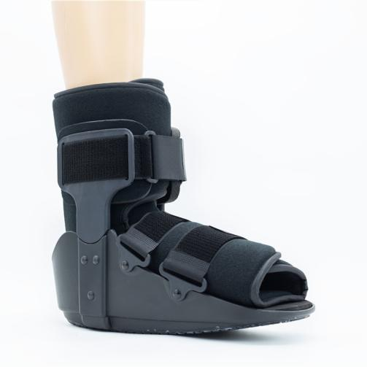

**Common Examples of Use**

**Ankle and foot stability fractures.**

**Severe ankle ligament sprain.**

**Used after ankle and foot fractures, reduction or internal fixation surgery.**

**Postoperative fixation of Achilles tendon repair (adjustable to forefoot weight-bearing position and heel non weight-bearing condition).**

**Early removal of plaster was used to protect unhealed fractures or tissues.**

**WARNING:**

**This product should be given by an treating doctor and applied by a professional. Application should be done with great care to ensure correct fit and efficiency of the brace. For hygiene reasons, it is proposed to be used by a single patient. Recommended product use up to 2 years.**

**WASHING INSTRUCTIONS:**

Check the condition of the product before use. If it is worn off, it needs replacement.

Hand wash with cold water. Use a soft detergent and remove the pads.

Allow to dry on its own. Do not wash it in a washing machine or dry it in a tumble dryer.